Gloucestershire Hospitals
NHS Foundation Trust

Learning & Development Department
Redwood Education Centre
Gloucestershire Royal Hospital
Great Western Road
Gloucester
GL1 3NN
 03004 225111

Induction, Training and The Trust Training Matrix

Dear Doctor,

Welcome to Gloucestershire Hospitals NHS Foundation Trust.

Employees of the Trust are required to read and complete the Trust’s Code of Conduct (whch includes Data Protection and Code of Confidentiality) within the first four weeks of their employment. This can achieved by accessing the Trust’s eLearning system where an account has been set up for you. (Please see instructions for accessing the eLeanring system on the attached page).

As you will not be based on Trust premises there is an expectation that you will carry out an appropriate induction as directed by your host service which will be relevant to the environment in which you are working (this should be repeated for every rotation). In addition your host service will inform you of training they require you to complete.

All Gloucestershire Hospitals Trust training is, of course, available to you, but our face to face elements may not be a practical option for you to undertake due to your georgraphical location. However, the Trust’s Learning Management System is available from any computer. A selection of eLeanring topics have already been loaded into your eLearning account and are ready and waiting for you should you wish to choose this method as a means of completing your training. Evidence of completion of eLearning is available by printing reports direct from the eLearning system.

For your information, if you were based in the Trust you would have to complete Corporate Induction and Mandatory Training relevant to your role. This is a professional requirement to fulfil internal and external standards (NHS Litigation Authority, Care Quality Commission etc) and an essential element in improving patient safety.

Training requirements for a doctor working in our Trust can be viewed in the Trust Training Matrix which you can access using THIS LINK. The Training Matrix provides staff with information on how the training can be achieved (i.e. face to face or eLearning), how often the topic has to be updated (i.e. annually / every two years etc) and offers hyperllinks to the eLearning system. In the event of you wishing to undertake any face to face training you will need to contact the Learning and Development Department on 0300 4225111.

If you require any information on the services the Education, Learning and Development Department offers please feel free to view our web pages which you can access using THIS LINK.

Julie Connell
Head of Induction & Mandatory Training
Gloucestershire Hospitals NHS Foundation Trust

How to Access the Trusts eLearning

If you have any problems whilst running or trying to access the eLearning please call 08454 226093 or email elearning.ghft@glos.nhs.uk

Courses can be accessed with or without headphones
Before you can access the elearning system you need to log on to a computer, if you do not have access to a computer or do not have a Trust IT account, please contact the elearning team on 08454 226093.

To begin

Please navigate to the eLearning System which can be found at https://nhssw.e2train.com/ghft or please find the link on the eLearning information page on the intranet.
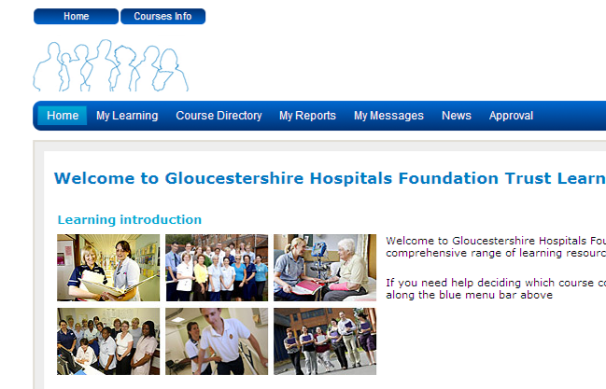
You will then see this screen (eLearning Homepage), please click on the My Learning Tab.
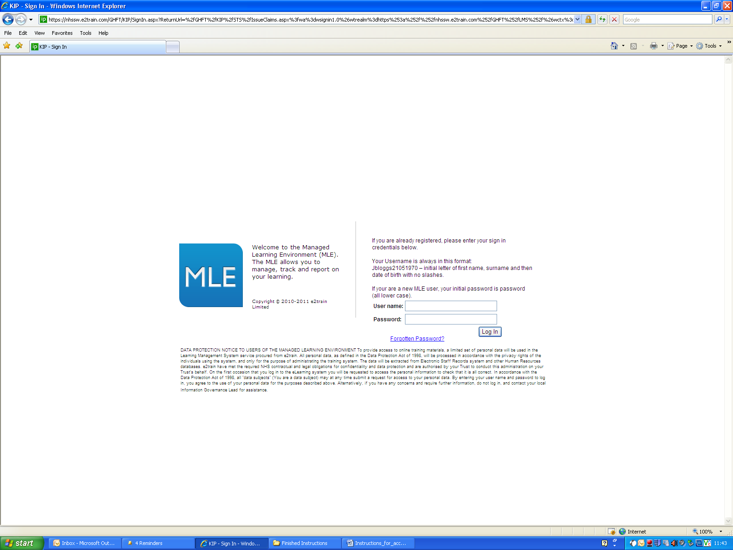
Your User name should be First Initial, Surname and Full Date of Birth, e.g. JBloggs28031975

Password will be “password” until you are prompted to change it.

Click Sign In.
1
2

3
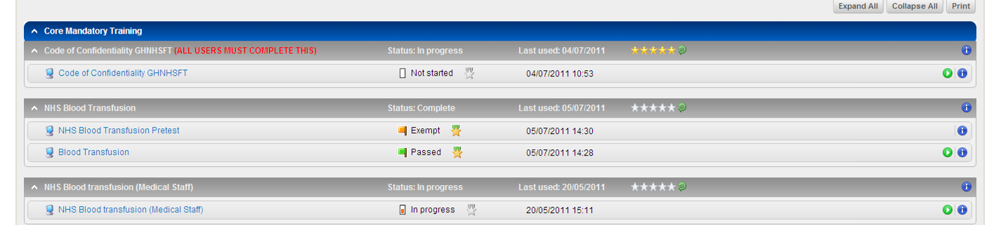
To launch a course simply click on the title.

5
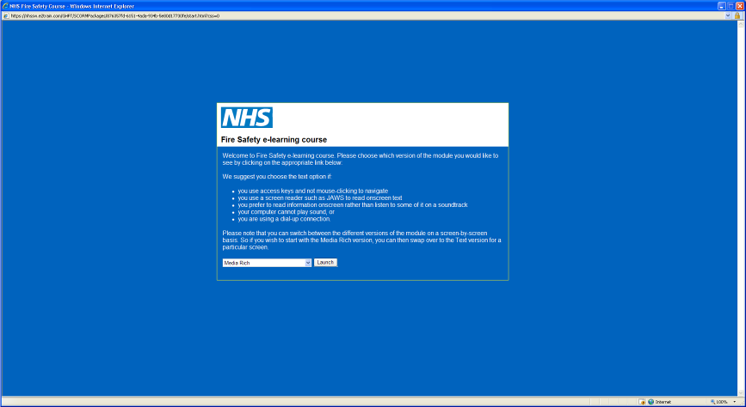
The course will then appear, ready to be completed.
4

If you have any problems whilst running or trying to access the eLearning please call 08454 226093 or email elearning.ghft@glos.nhs.uk

