The Severn Educational Resources page
A Users Guide to the Educational Resource Locator
The Electronic Resource Locator (ERL) has been developed by Severn Deanery in conjunction with the Welsh Deanery, and has received input from all the Deanery approved Education Provider Organisations within Severn. It is designed to supplement, not replace, local sources of information. Although it builds on the functionality of the Severn Appraisal Toolkit, it can also be used in isolation. It is suitable for all grades of health professional.

USER’S GUIDE
The ERL is divided into 2 sections.
The ERL Browser allows the user to search for educational courses and other learning events or sites according to their own learning need, whether arrived at informally through self reflection, or formerly through the Appraisal process.
The Event Listing section provides details of courses available as well as other potential useful learning opportunities.
Here is the opening page
http://gpappraisaldemo.severndeanery.nhs.uk/
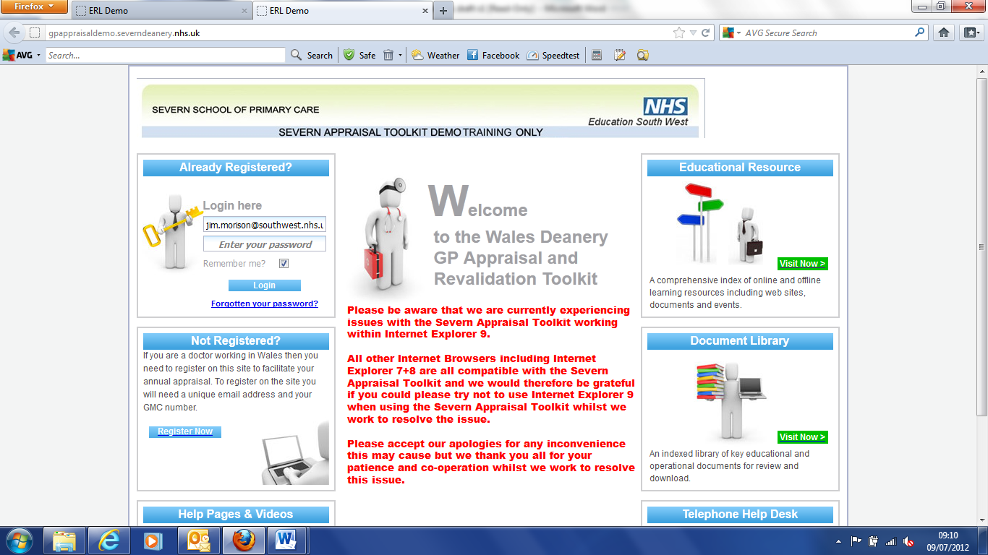
Click on Educational Resource|Visit Now which will take you to this page:
http://gpappraisaldemo.severndeanery.nhs.uk/default/erlmaterial/index

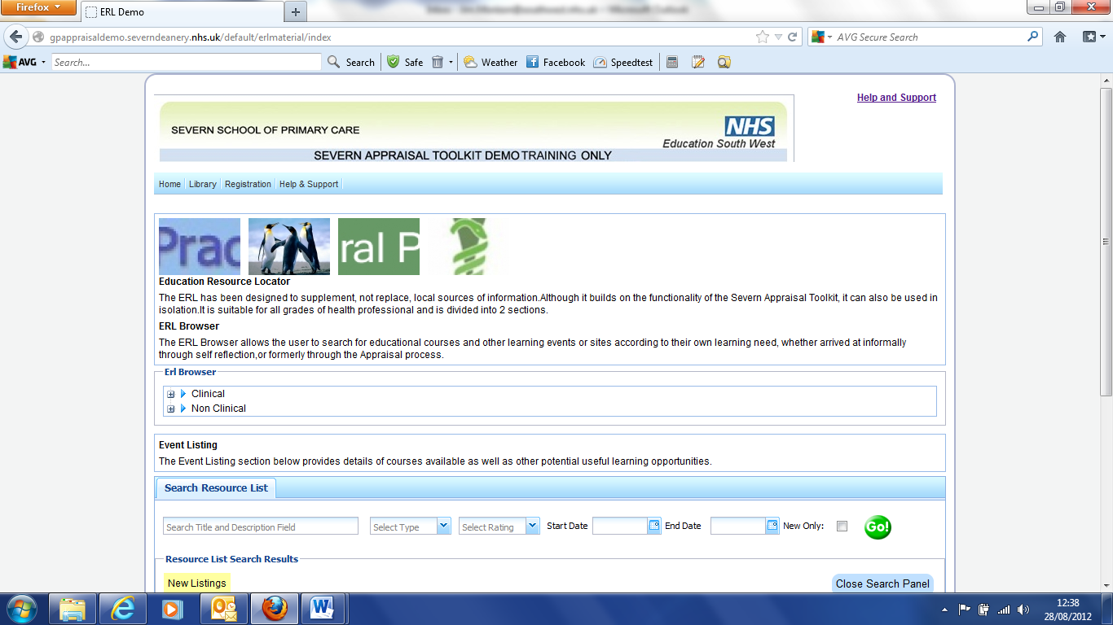
It has a list of resources which can be accessed in 2 ways.
- As an ERL Browser
Expand ERL browser to offer you a variety of clinical subjects. These can be explored to identify particular areas of clinical learning needs

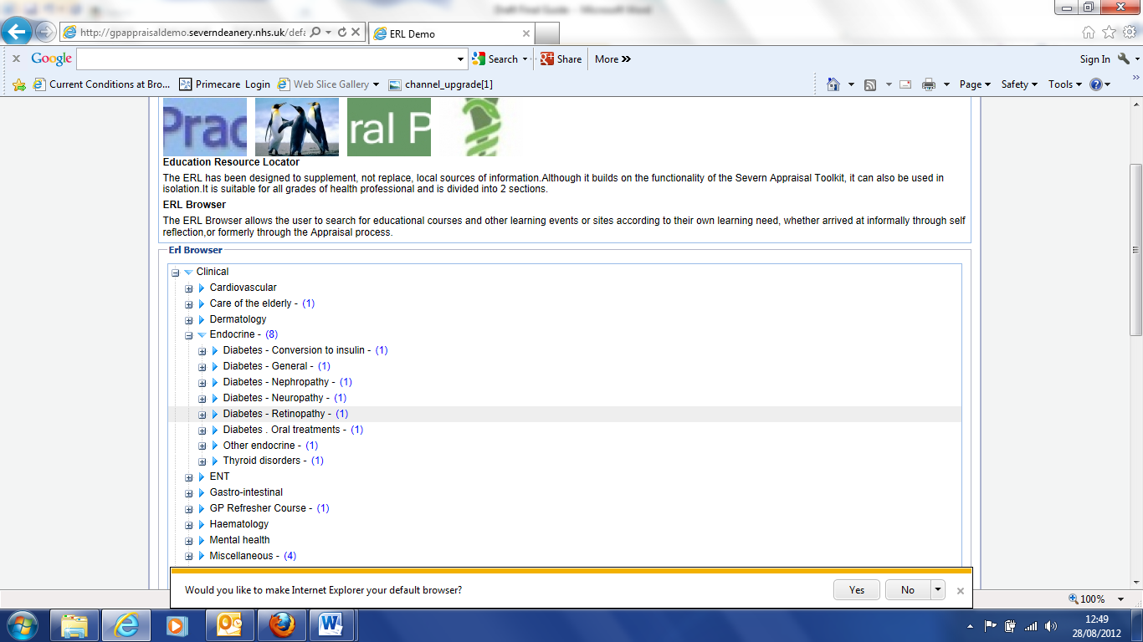
Click the identified area to bring up a screen detailing where the course can be accessed and what its content will be.
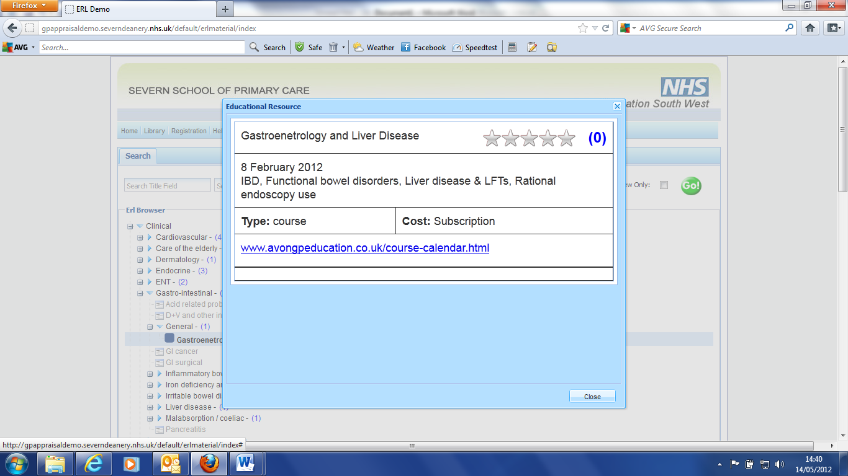

From where you can click on the details supplied by the provider www.avongpeducation.co.uk
2. As a list of events
Scroll down the panel headed “Resource List search Results”
http://gpappraisaldemo.severndeanery.nhs.uk/default/erlmaterial/index

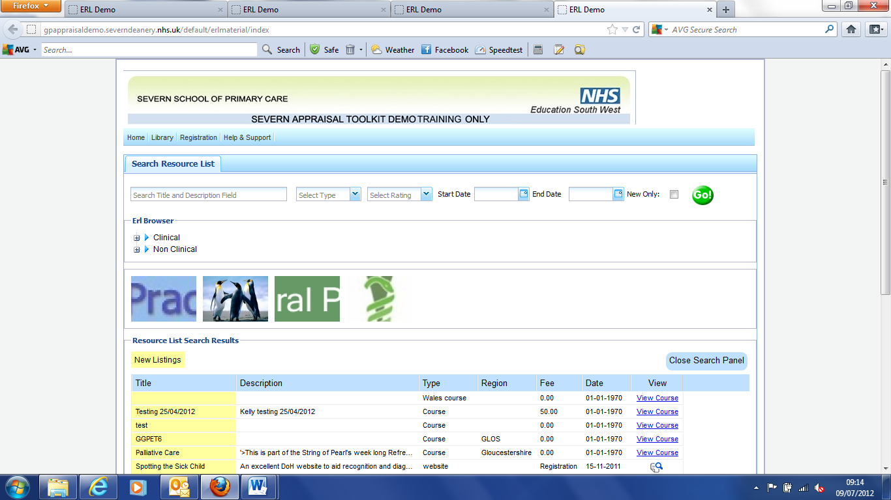

The Events can be easily searched using the “Search Resources “
By default, all events are shown

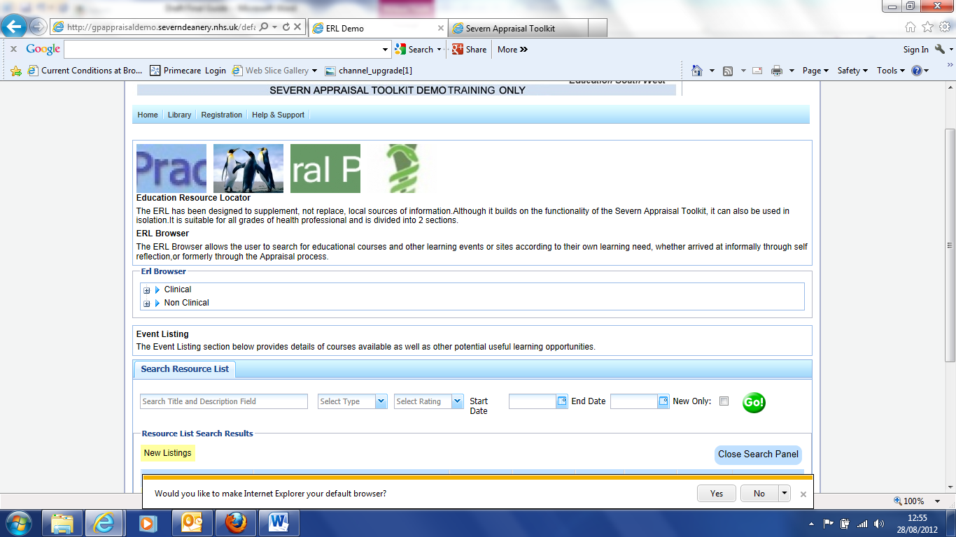
You can narrow your search by being selective on the “Search Resouces list” tab. In the Screenshot below, type in a search option in “Search Title & Description Field” and press “Go”

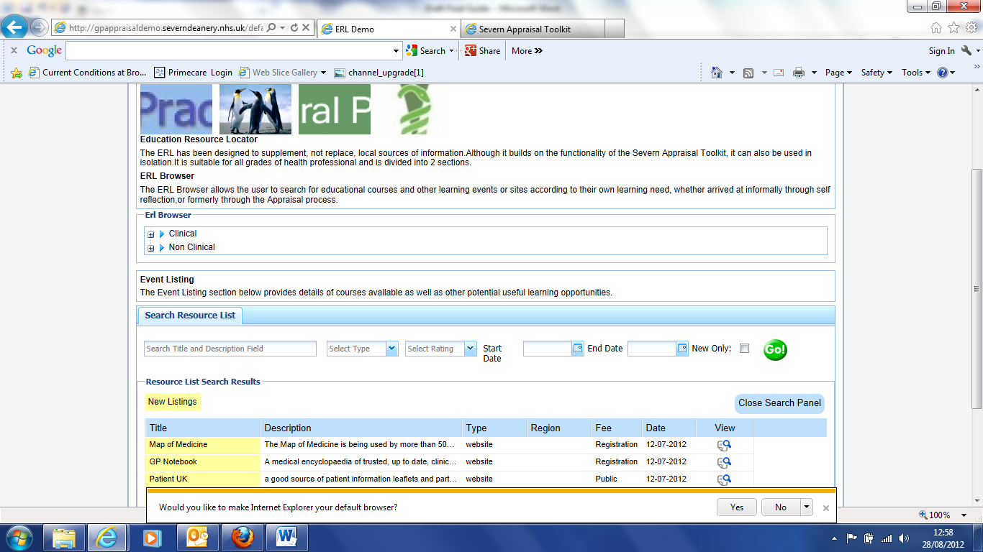

Similarly, the site can be searched using “Description”, “Type” etc

The Events Listings (Resource List Search Results) have 7 columns of information (Title, Description, Type etc)
Each column can be grouped either alphabetically or by date by left clicking on the little arrow beside the column heading.

More details of the course can be viewed by selecting either alternative in “View”,
(a “magnifying glass” or “view details”. )The two screens below show the layout for each of these alternatives, which will depend on details supplied by the Education Provider Organisation. Links within the screens will take you to the Course Providers site where more details, booking etc are available
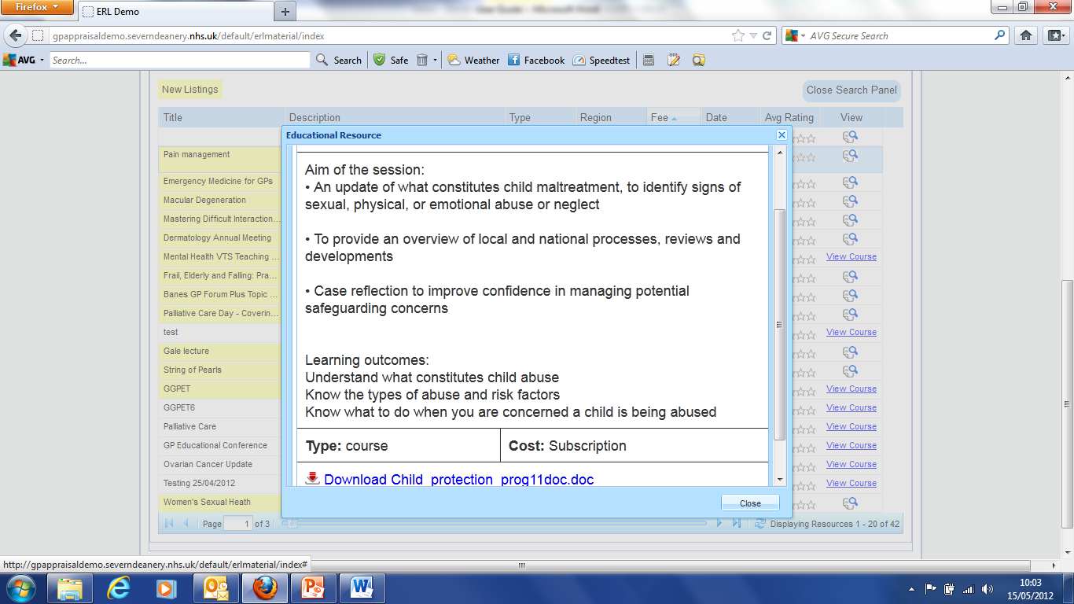
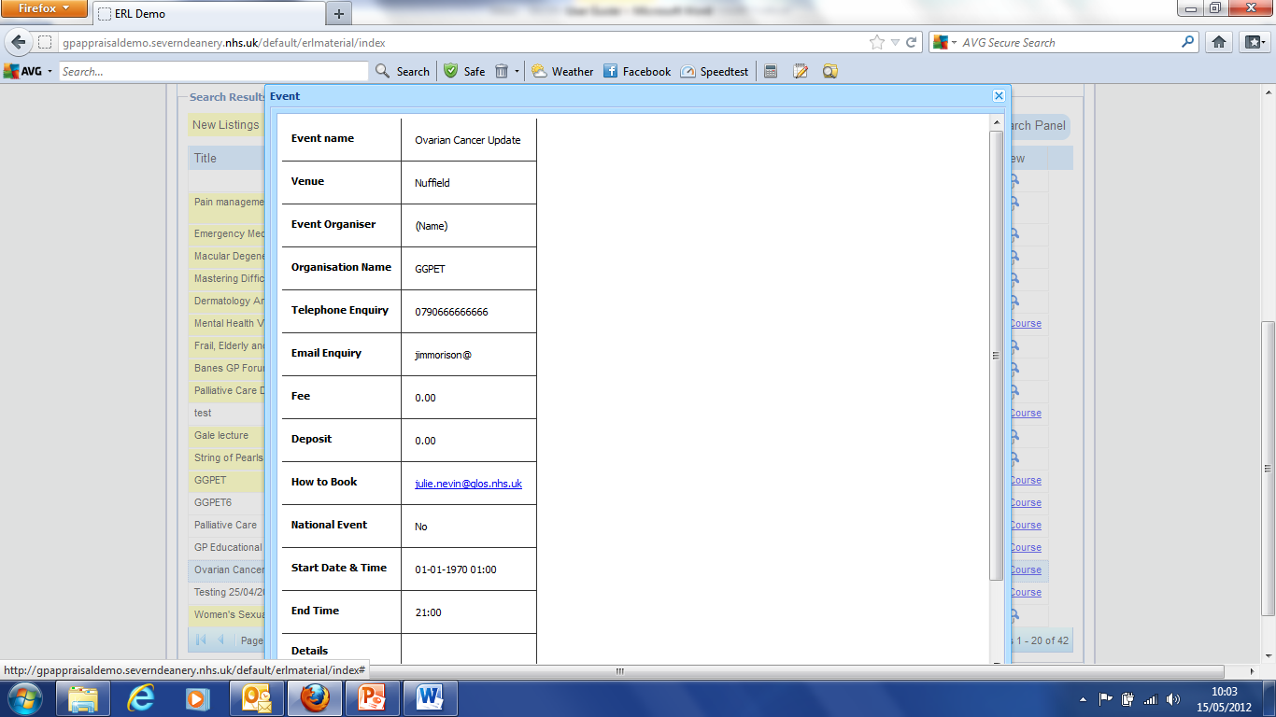

Jim Morison September 2012

