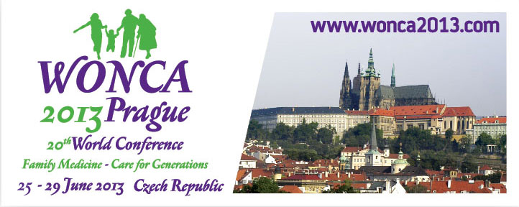
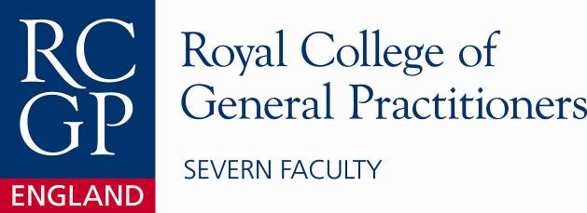
With support from Severn Deanery




20th WONCA World Conference

Sponsorship for Severn Faculty GP Speciality Trainees and members within 5 years of completing training

Severn Faculty RCGP with support from the Severn Deanery would like to offer sponsorship to attend the WONCA World Conference in Prague 25th - 29th June 2013

Sponsorship is supporting the Vasco da Gama movement (www.vdgm.eu)


The Vasco da Gama Movement (VdGM) forms part of the WONCA organisation and is the European International Committee for GP trainees and GPs within 5 years of completing training. The WONCA World Conference this year is themed on “Family Medicine – Care for Generations” and will be held in Prague, Czech Republic

http://www.wonca2013.com/en/home

The benefit of attending this conference is for young doctors to share experiences and forge links worldwide.

Sponsorship is available for ST2, ST3 trainees and/or newly qualified GPs (first 5 years) to attend the conference in 2013. Entry is by competition, open to Severn Faculty trainees and “First 5” GPs. Unsuccessful applicants may consider applying for a Vasco da Gama bursary
http://www.vdgm.eu/index.cfm/spKey/about_us.news/spId/ADE739DA-03ED-7F7A-478064B8535C577D.html

Severn Faculty RCGP are able to fund up to a maximum of £750 each to attend the Conference for up to two successful candidates (terms available on request).

Application is by competitive essay, maximum 600 words

“How might a European perspective of UK General Practice
be relevant to a Severn GP or trainee”

Along with your application, contact details, current status (either Speciality Trainee or within 5 years of completing GP training, please include details of where you are working within the Severn Faculty, Deadline 28th February 2013

Applications can be sent either by email to: severn@rcgp.or.uk or by post to:
Jane Lohmann, Severn Faculty RCGP, Deanery House, Unit D- Vantage Business Park,
Old Gloucester Road, Hambrook, Bristol, BS16 1GW Tel: 01454 252728

