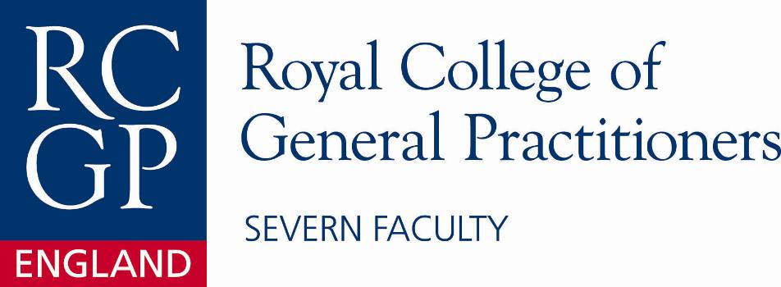

Applied Knowledge Test (AKT)
One Day Preparation Course for the MRCGP Exam

7th March 2013

Engineers’ House, Clifton, Bristol, BS8 3NB

A one day RCGP accredited course preparing for the Applied Knowledge Test of the MRCGP, to
include methods of preparation, statistics for the MRCGP exam and a mock AKT paper.

Cost: £50 Deposit required by Severn Deanery/Faculty Members
£165 for associate members/Associates in Training
£225 for non members of RCGP

Please reserve me a place on the AKT Preparation course for the MRCGP Examination on
7th March 2013 – 08:45 – 17.00. Places will only be reserved on receipt of your cheque
and completed application form. Places cannot be reserved by e-mail or phone.

(Please tick the statement(s) below which apply to you):

□ I am a member of the Severn Deanery (Institute) and RCGP Severn Faculty and enclose a deposit cheque of £50.00 which will be returned during the course
□ □ I am an RCGP member/Associate member/Associate in Training and enclose a cheque for £165.00
- I am a non-member and enclose a cheque for £225.00

Please make your cheque payable to ‘Severn Faculty RCGP’ and for deposit cheques please post-date to
the first day of your course

FIRST NAME: ……………………………………………………………SURNAME:.………………………………………………………

ADDRESS: …………………………………………………………………………………………………………………………………….

……………………..………………………………………………………POSTCODE:…………………………………………………….

TEL NO: ………………………………… STATUS: ……………………………………… GMC NO ……………….…………………

SURGERY (Name & Address) .…………………………………………………………………...…………………………………………

RCGP Membership Number …………………………………………… Severn Institute Member: Yes/No – delete as appropriate.

E-mail address: ………………………………………………………………………………………………………………………………..

Please return your fully completed form to the RCGP Severn Faculty office:

Events Administrator, Severn Faculty RCGP Royal College of General Practitioners, Deanery House, Unit D - Vantage Business Park, Old Gloucester Road, Hambrook, Bristol, BS16 1GW.

If you have any queries please email severn@rcgp.org.uk or telephone 01454 252728/29

PLEASE NOTE: Members of the Severn Deanery (Institute) have their place funded by the Deanery. Despite this, your place is not guaranteed. It is therefore imperative that you apply by post, with your deposit to the SEVERN FACULTY office. This course is available for AiT’s across the country to apply, although priority goes to Severn Deanery members. Places are limited and usually sell out quickly therefore prompt application is necessary.
Terms and Conditions of booking:

- Registrations will only be confirmed on receipt of the full course fee or deposit if you are applying for a Severn Deanery funded place. Completion of this registration constitutes a legally binding agreement to the terms and conditions.

- Places are allocated on a first-come-first-served basis.

- Your place is not guaranteed until you have received confirmation from RCGP. Confirmation will be emailed to you upon successful completion of the registration process.

- A confirmation will be sent to you once payment is received by the RCGP.

- All cancellations must be made in writing to the course organiser. Cancellations received up to 4 weeks before a course will be granted a full refund, less a £35 administration fee. No refund will be granted to courses charged at £35 or less. For cancellations made less than 4 weeks before a course, the RCGP will retain the full cost of the course. If you register for a free-to-attend course, you must advise the course organiser of any cancellation.

- In the unlikely event that the RCGP has to cancel a course or event, registered delegates will be refunded in full. Unless the course or event is cancelled by the RCGP, no refunds will be granted for failure to attend because of reasons beyond the RCGP’s control. However, substitute delegates will be accepted but please notify the course organiser in writing of any name changes.

- If you wish to change to another course, you must notify us in writing no later than 4 weeks prior to the original course you have booked. We will then withdraw you from your original booking and issue you a full refund, less a £35 administration fee. You will then need to book yourself onto the course you prefer. For any change notifications made less than 4 weeks before a course, the RCGP will retain the full cost of the course. If you register for a free-to-attend course, you must advise the course organiser of any changes.

- The course organiser will contact you prior to the course with further information. If you have not heard from the course organiser 7 days before the start date of the course, it is your responsibility to contact them to ensure your place is booked. Contact details of the course organiser will be included both within the online course details and your confirmation email.

