
School of Primary Care

Established Trainers’ Courses

2-Day Residential Courses
at
Guyers House,
Pickwick,
Corsham, Wiltshire

27^{th -} 28th April 2011
15^{th -} 16th September 2011
20^{th -} 21st October 2011

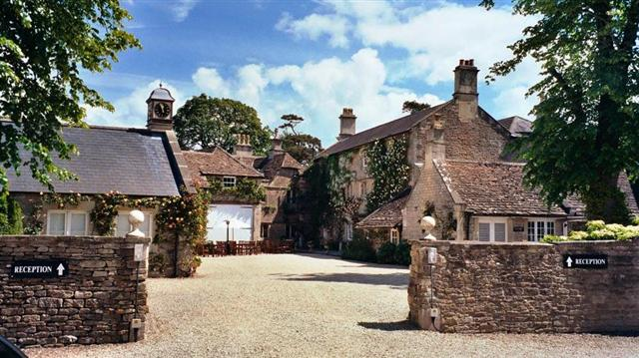

Spend two days in a splendid country house hotel in Wiltshire:
- Sharing experiences, successes and problems with other GP trainers from all corners of Severn Deanery. Checking how you do things in comparison with your peers. Getting practical help with preparing and delivering tutorials and the nMRCGP assessments. Getting refreshed and reinvigorated as a trainer
- Each GP trainer needs to attend such a course during their 3-year re-approval period
- The cost of this course is £300.00 including £100.00 for evening meal, overnight accommodation & breakfast; £200.00 will be reimbursed shortly after course attendance. We will invoice your practice for this fee after booking confirmation. This fee is not refundable or transferable should you cancel your booking within eight weeks prior to course commencement. Please refer to our cancellation policy.

School of Primary Care

Established Trainers Course
APPLICATION FORM – Please complete in Block Capital Letters

Name ………………………………………………………………………….

Name of GP Practice ………………………………………………………..

Address of GP Practice ……………………………………………………..

………………………………………………………………………………….

………………………………………………………………………………….

Email Address ………………………………………………………………..

Telephone No. ……………………………………………………………….

Please confirm you wish to stay overnight on Day 1 …………………….

Preferred Date – Please tick ONE only
□ Wednesday & Thursday, 27th- 28th April 2011
□ Thursday & Friday, 15th-16th September 2011
□ Thursday & Friday, 20th- 21st October 2011

I agree that my practice can be invoiced for this course fee.

Signed ………………………………….. Date ……………………………

Please Apply to:-

Jackie Pullin
GP Co-Ordinator, School of Primary Care
Deanery House, Unit D, Vantage Business Park
Old Gloucester Road, Hambrook, Bristol BS16 1GW

Tel No: 01454 252682
Email: jacqueline.pullin@southwest.nhs.uk

